ITD105 Semester 2 2025 – Submission Template

Student Name: Isaac Douglas Student Number: n12587958
Tutor Name: Mr Mark Walpole
MY SCRIPTS:
WARNINGS for Tasks 2-5:
Assignments that do not provide a detailed and complete screenshot of the results for all tasks or not follow the submission instruction for a given query will be awarded Zero.
The screenshot needs to include the SQL codes, result grid and action output.
Even if your results are in the SQL file/other attached file, your grade will remain zero. We need to follow the same rule for all students. So, please make sure to include a screenshot of the result/s as requested.
Any submission that attempts to provide a screenshot that does not result from the provided query will be awarded Zero.
Even, if you are getting Error message, you can submit the screenshot of the error message and possible reason. You might still get some mark for it!

You can make a screenshot in the following way: Windows <Cntrl + Win + S >, Mac <Shift + Command +4>. You can also use “Snipping Tool” to create screenshots.

The use of artificial intelligence tools (for example Chat GPT) is not permitted in any assessment in this unit. The use of such tools when not authorised may be treated as a breach of MOPP C/5.3 Academic integrity and appropriate penalties imposed.

Task 1 [4 marks]

<insert RMap>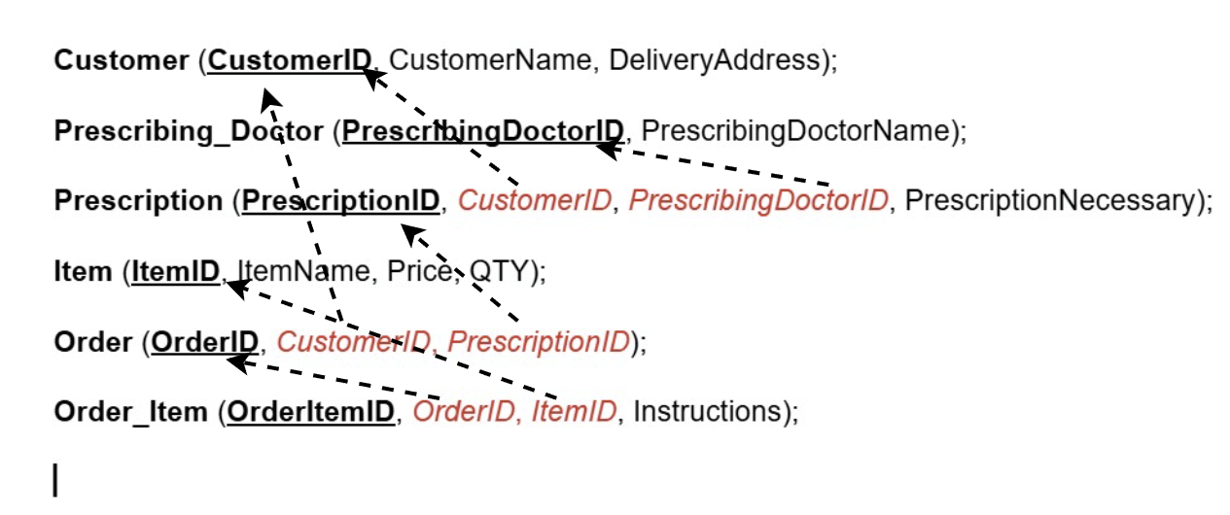

Task 2 [6 marks]
In addition to the screenshots (for all parts), include a SQL script in the file named "ITD105_3B_your_student_number.sql" with your submission. Make sure it clearly shows your script for Task 2.
Please note:
In the following tasks you will be using MySQL Workbench and any question that requires any SQL you must include a screenshot of the result from executing your query.
The screenshot needs to include the SQL codes, result grid and action output as per the example that follows.
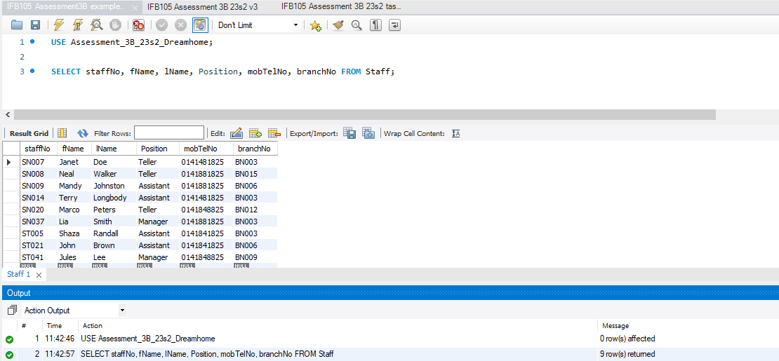
MINE: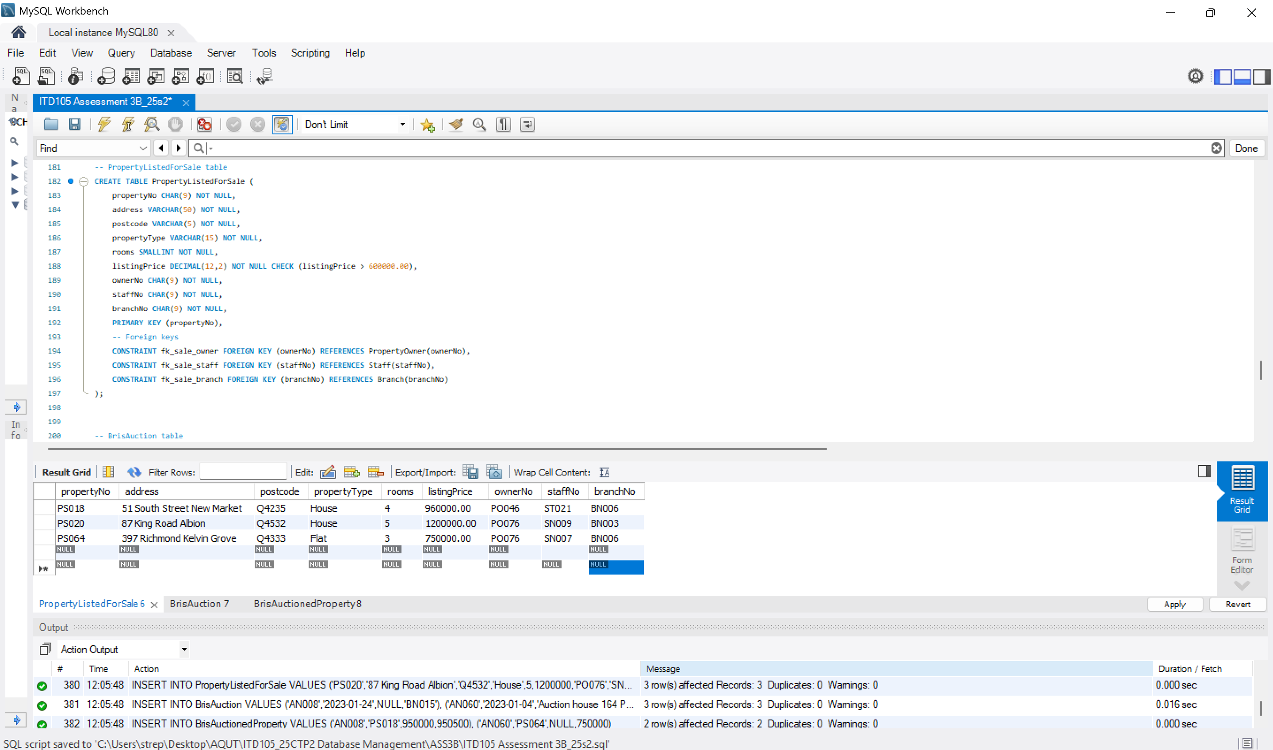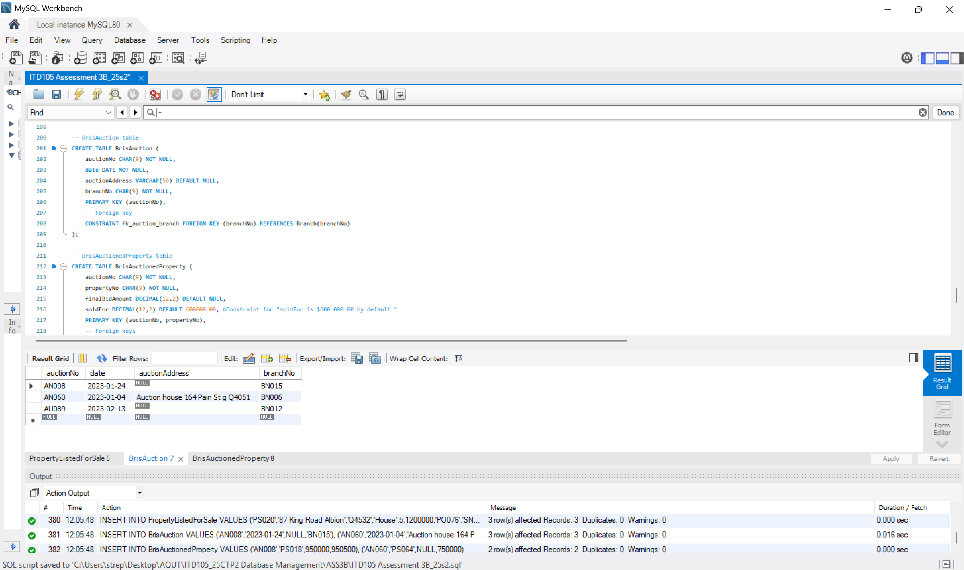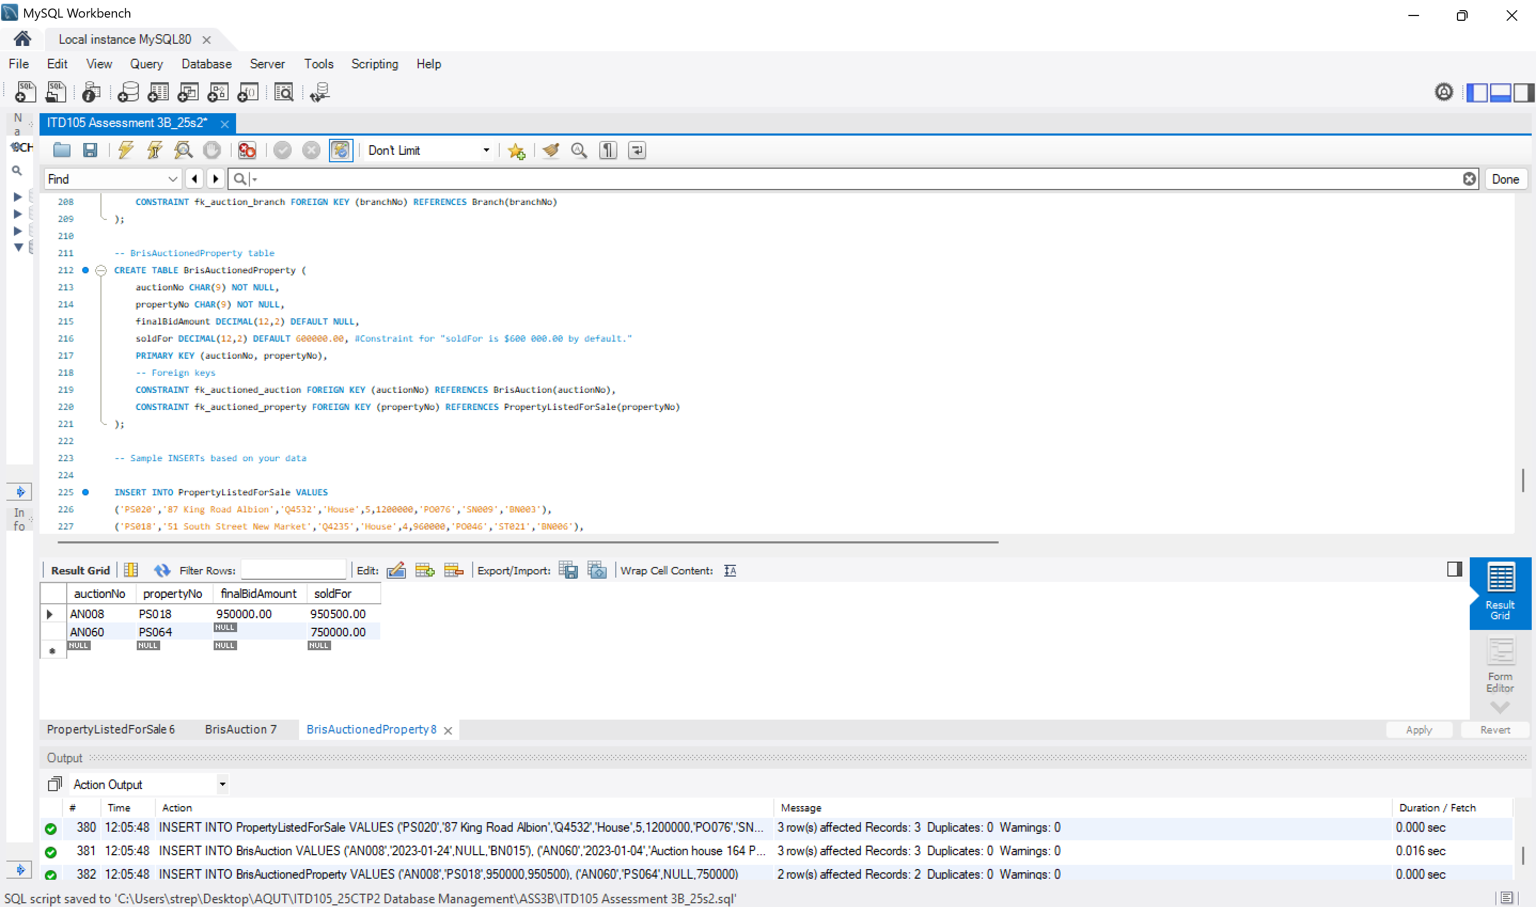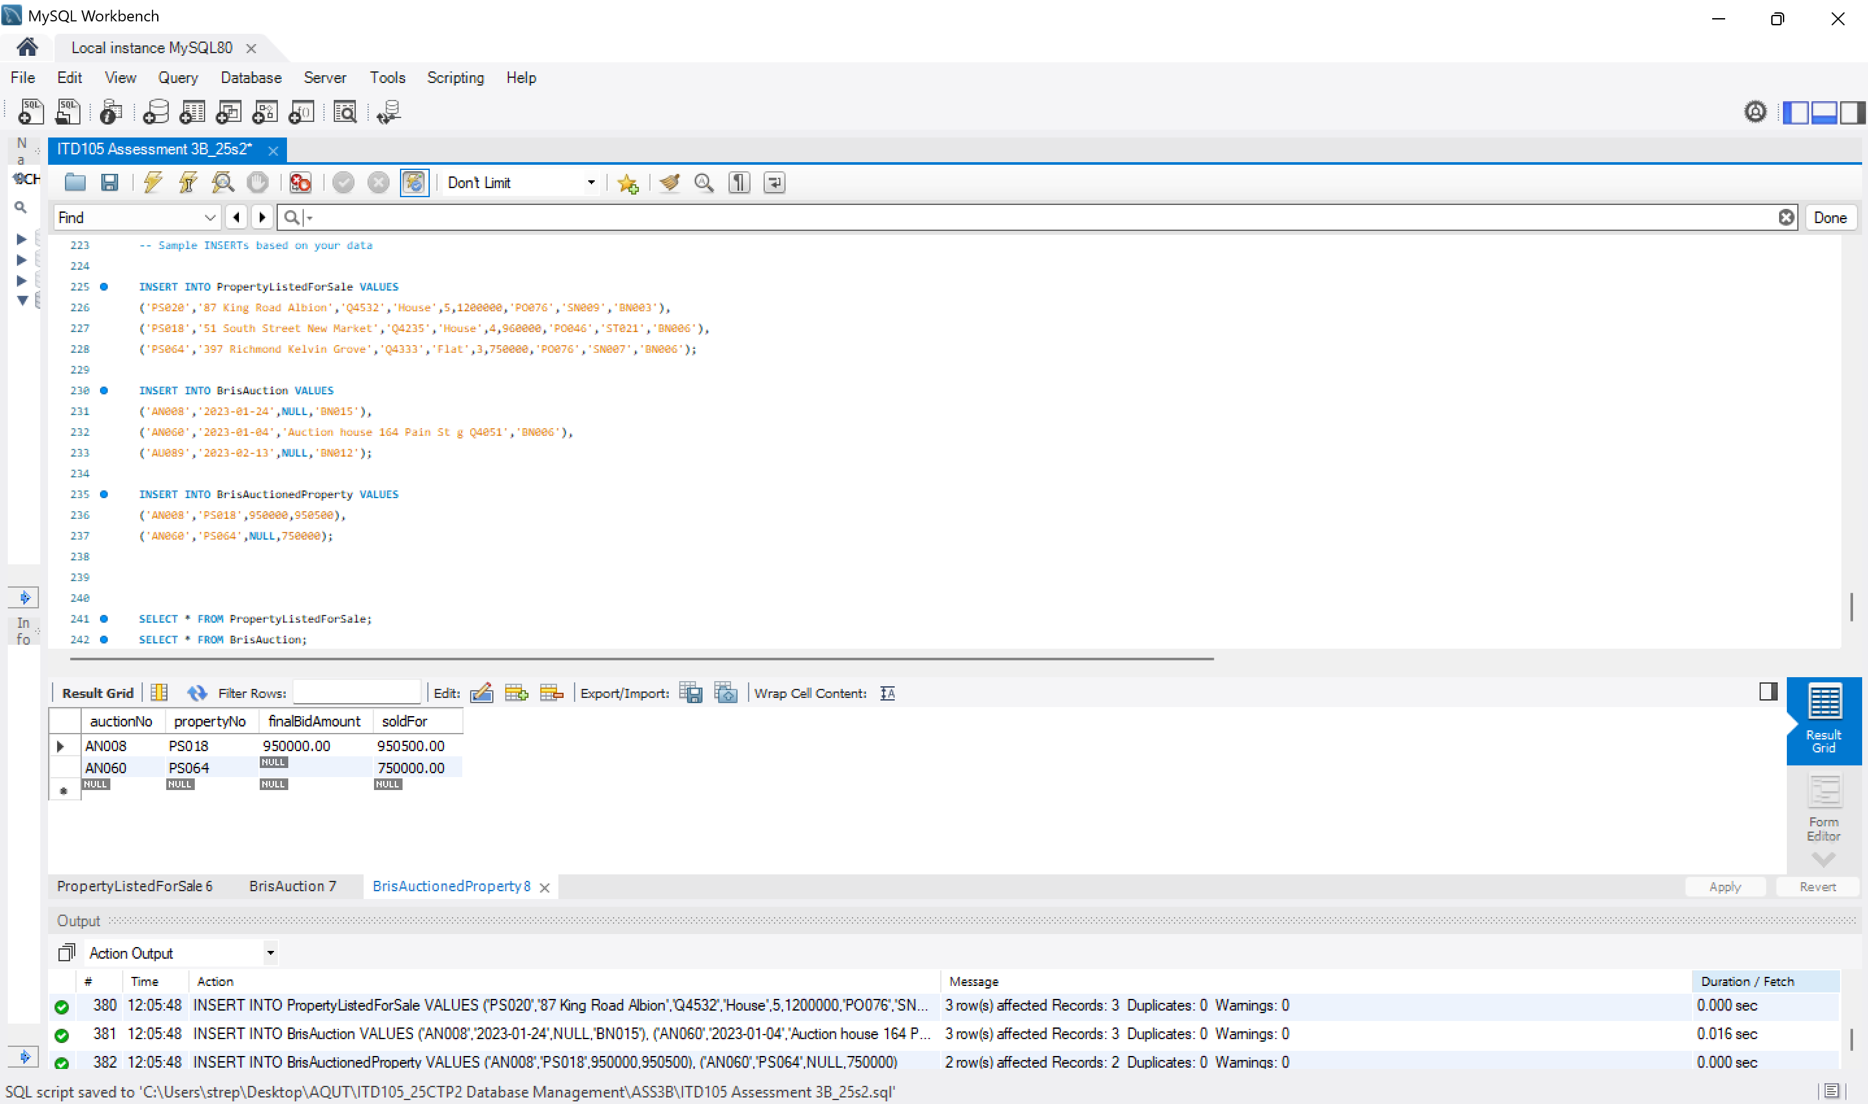

Task 3 [6 marks]

For each section:
<insert SQL statement>
SELECT clientNo, fName, lName, emailAddr, prefType, maxRent
FROM Client
WHERE prefType = 'Flat'
AND maxRent < 560;
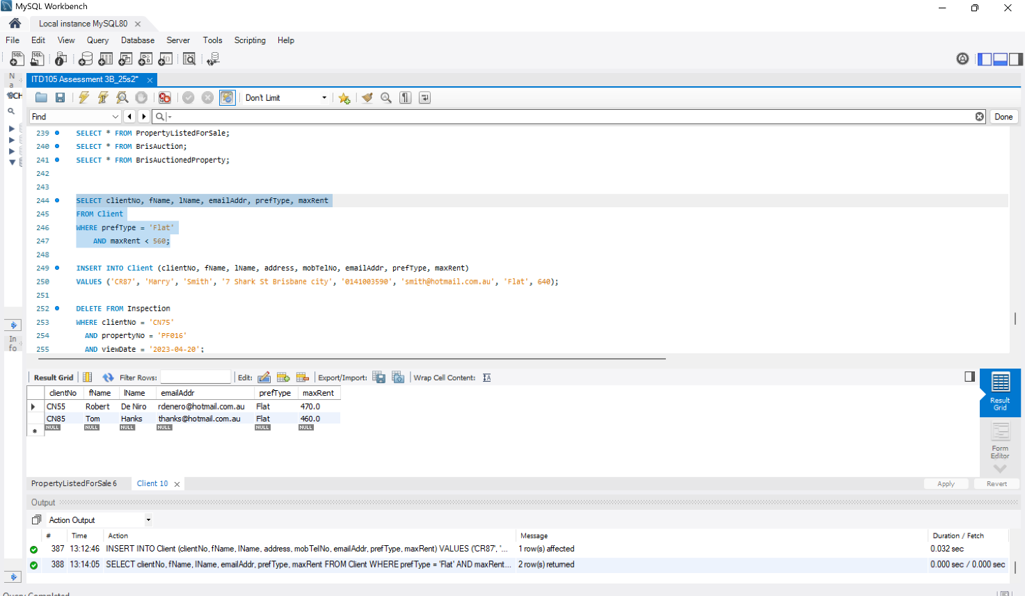

INSERT INTO Client (clientNo, fName, lName, address, mobTelNo, emailAddr, prefType, maxRent)
VALUES ('CR87', 'Marry', 'Smith', '7 Shark St Brisbane city', '0141003590', 'smith@hotmail.com.au', 'Flat', 640);

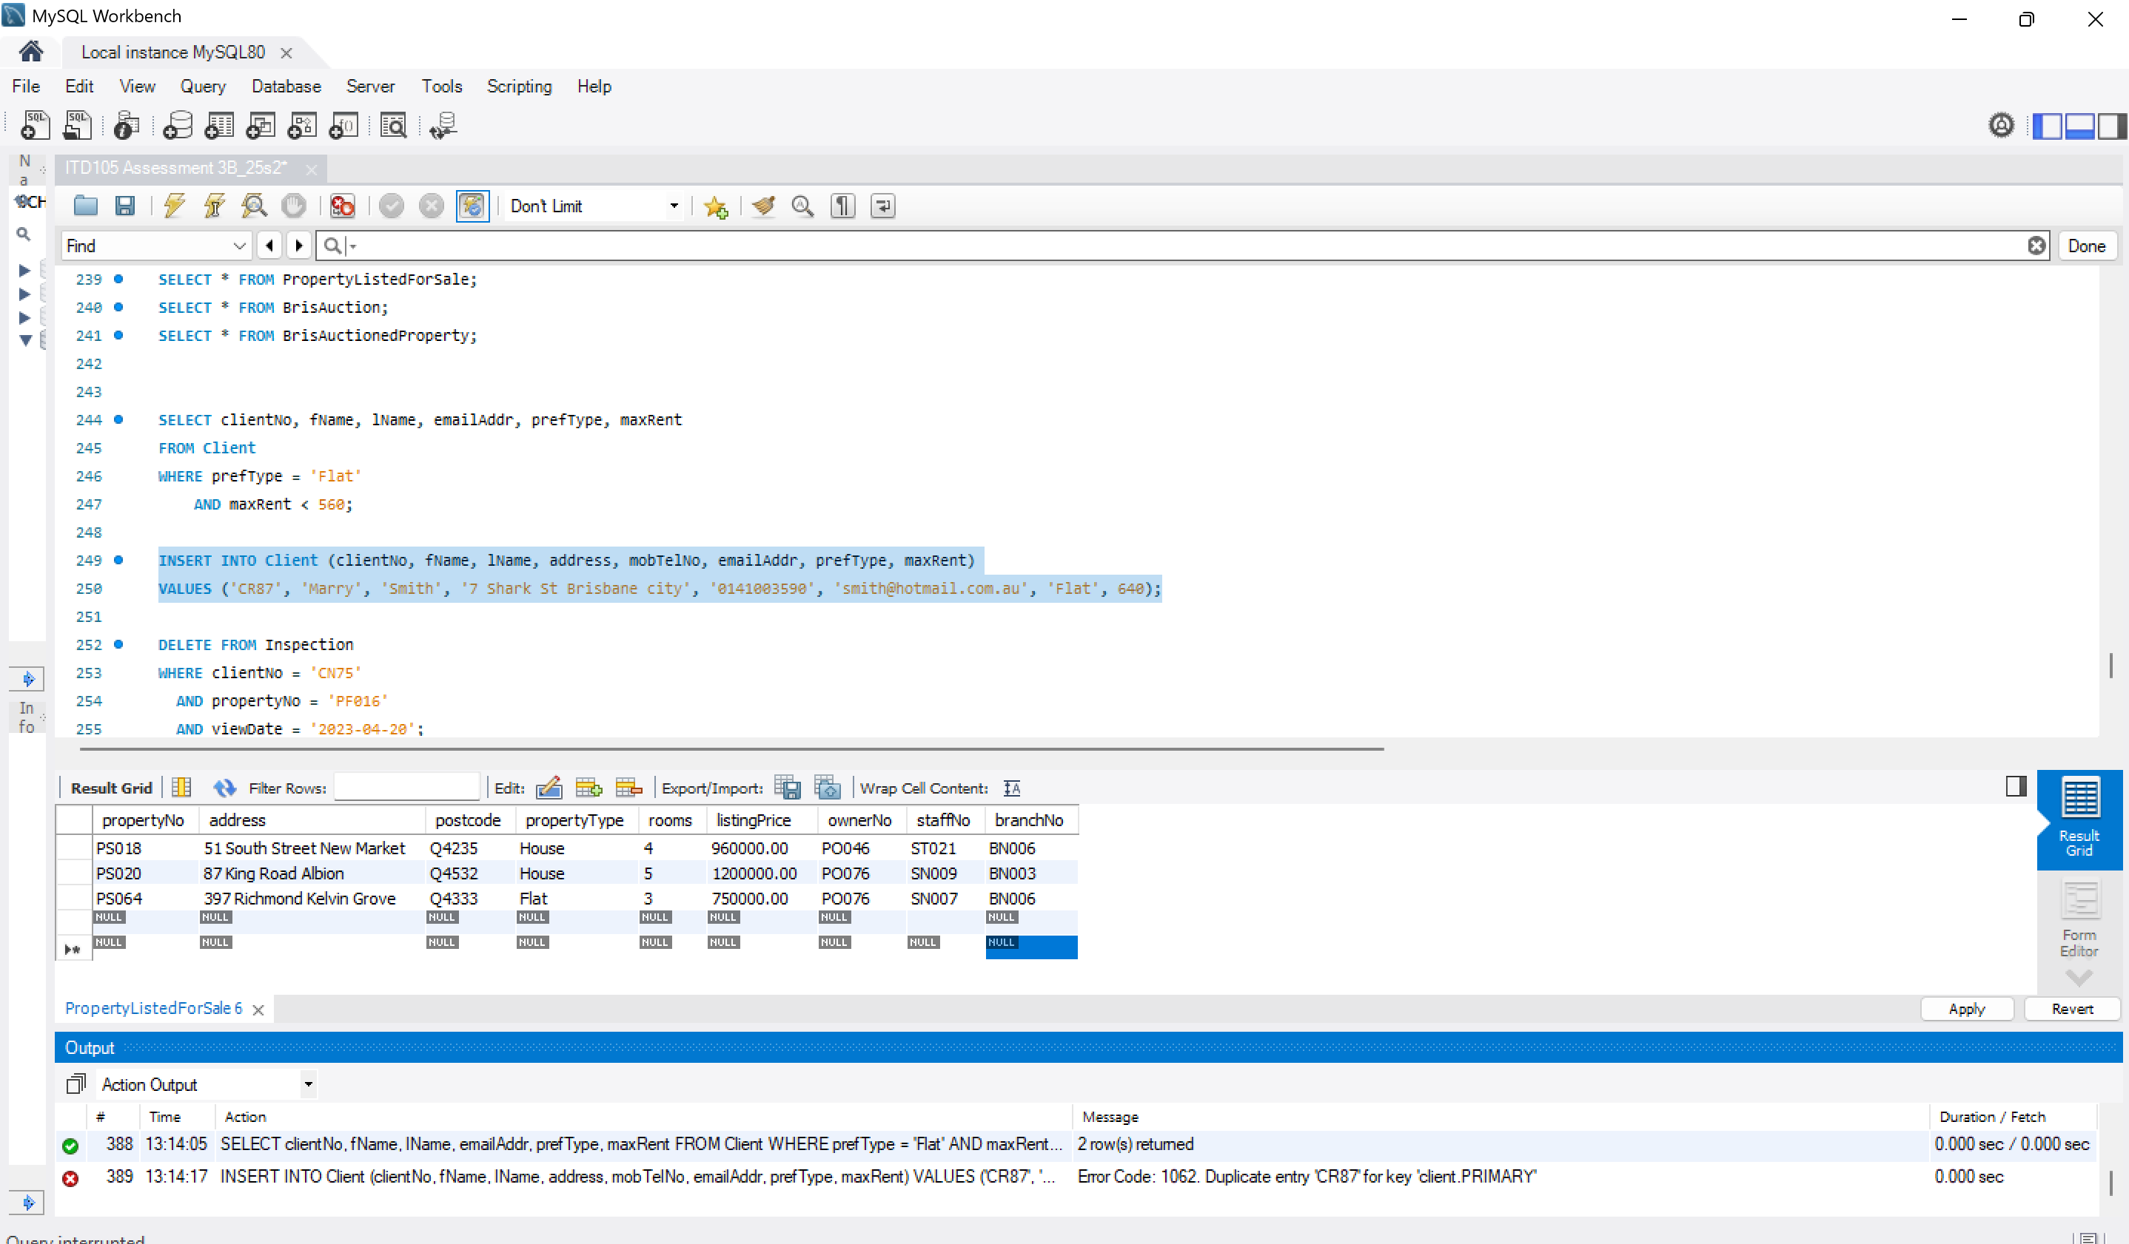
DELETE FROM Inspection
WHERE clientNo = 'CN75'
AND propertyNo = 'PF016'
AND viewDate = '2023-04-20';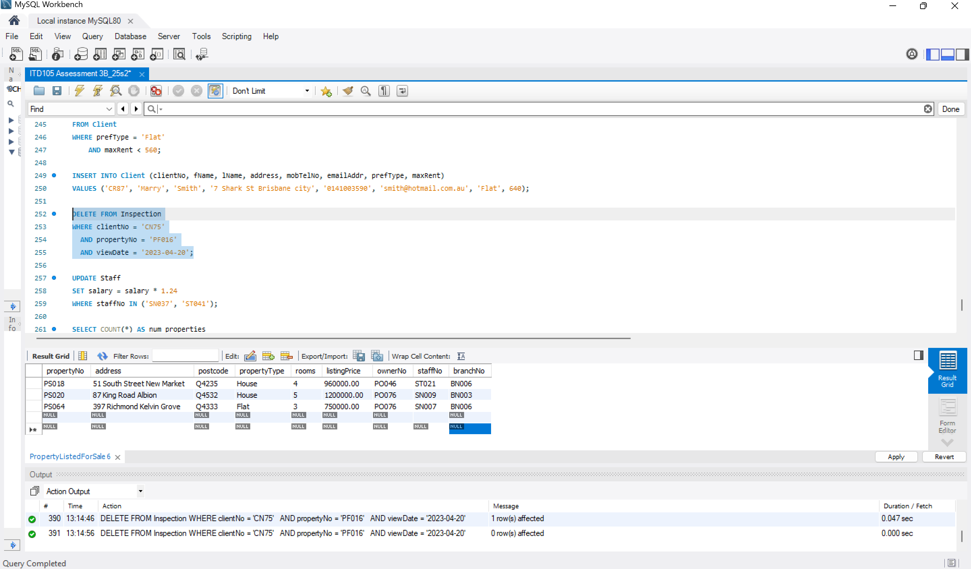

UPDATE Staff
SET salary = salary * 1.24
WHERE staffNo IN ('SN037', 'ST041');
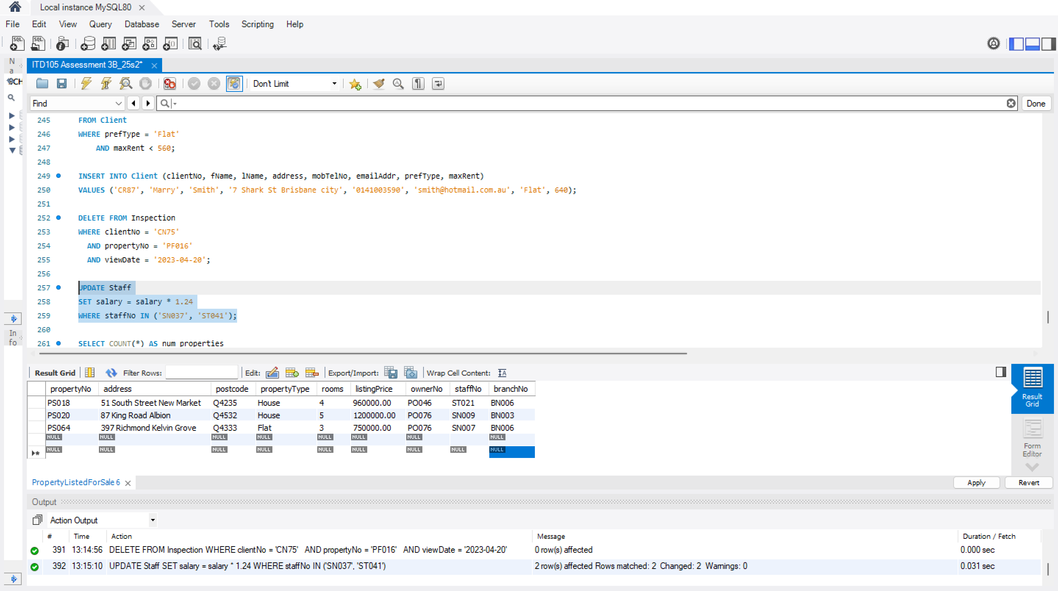
SELECT COUNT(*) AS num_properties #count all rows for PO046 in PropertyForRent and displau result in num_properties column
FROM PropertyForRent
WHERE ownerNo = 'PO046';
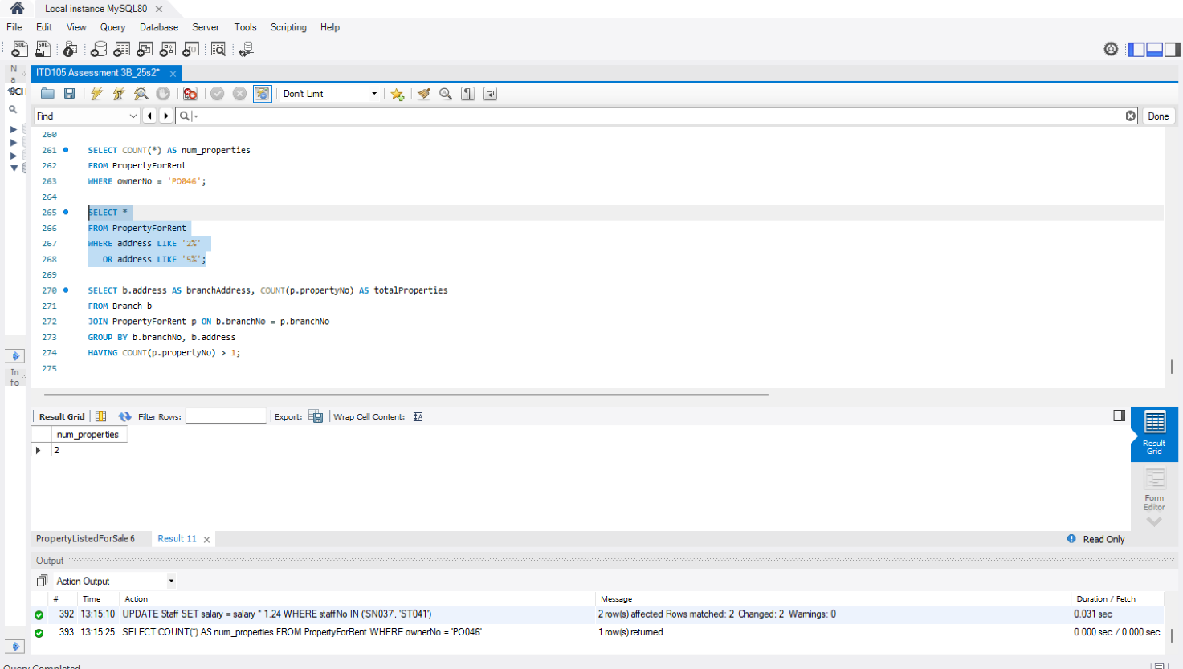
SELECT *
FROM PropertyForRent
WHERE address LIKE '2%' #% matches any sequence of characters after the starting character and LIKE is a matching operator
OR address LIKE '5%';
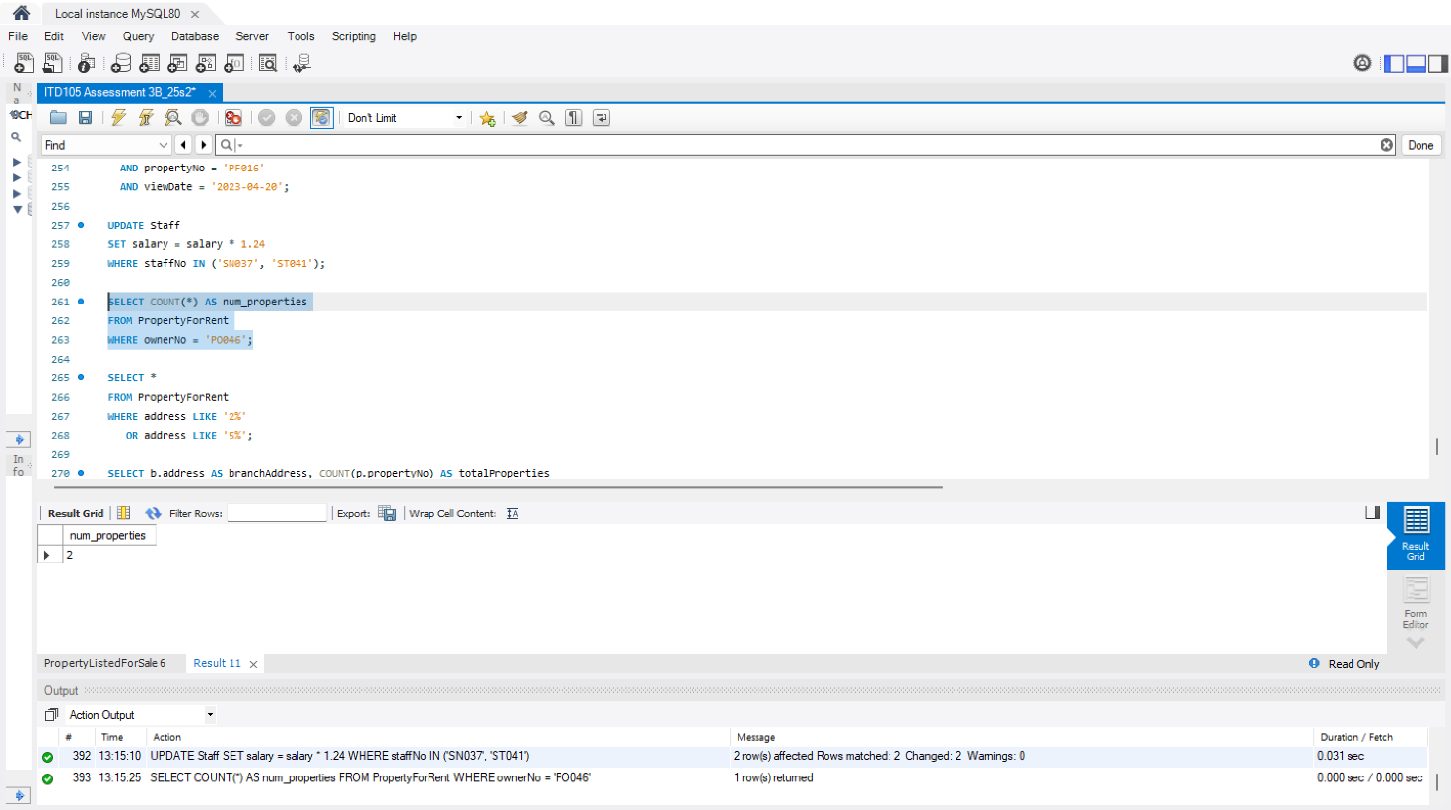
SELECT b.address AS branchAddress, COUNT(p.propertyNo) AS totalProperties
FROM Branch b #finds branches
JOIN PropertyForRent p ON b.branchNo = p.branchNo #joins branch to its properties
GROUP BY b.branchNo, b.address
HAVING COUNT(p.propertyNo) > 1; #displays properties over 1
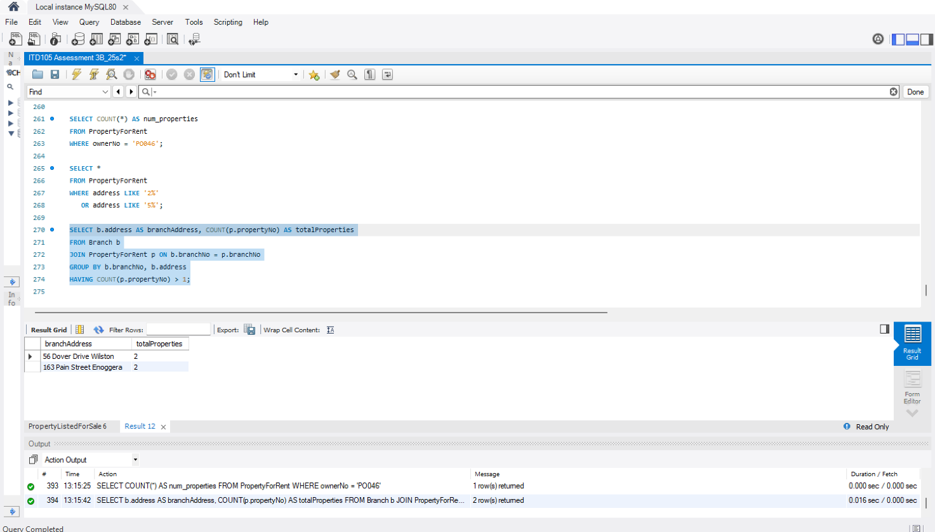
<insert screenshot as requested >
The screenshot (for all parts) needs to include the SQL codes, result grid and action output.

Task 4 [7 marks]

For each section:
<insert SQL statement>

SELECT *
FROM Client
WHERE clientNo IN (
SELECT clientNo
FROM Inspection
WHERE viewDate < '2023-05-15'
);
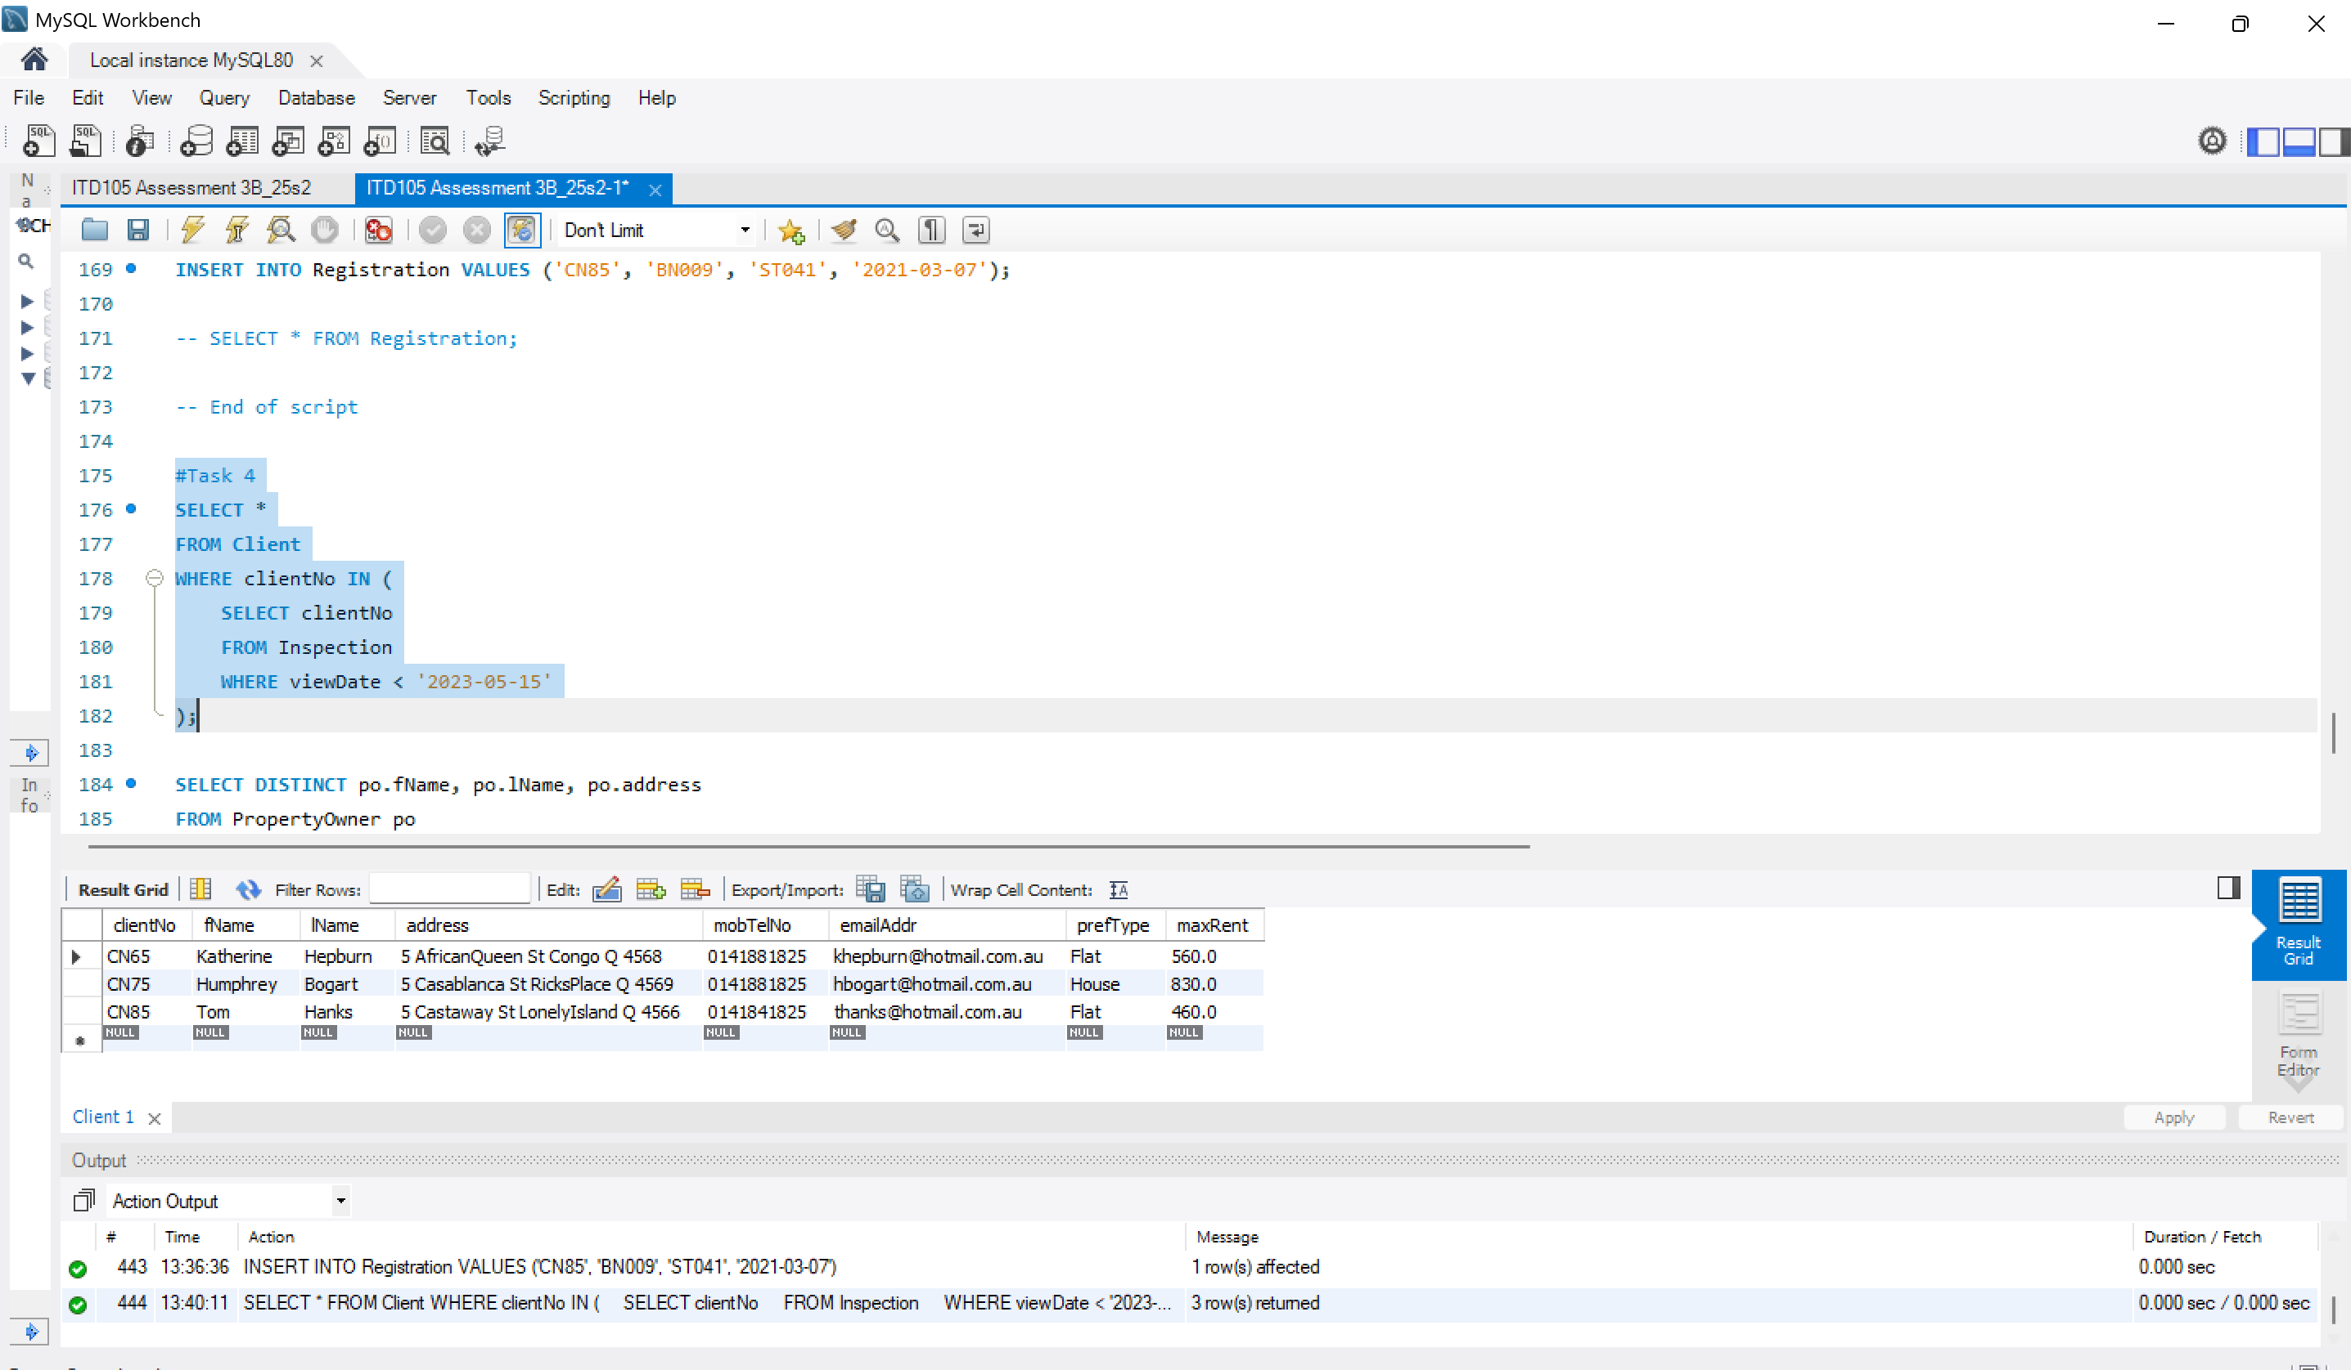
SELECT DISTINCT po.fName, po.lName, po.address #DISTINCT ensures each owner appears only once if they own multiple properties.
FROM PropertyOwner po #define the alias we used before "po"
JOIN PropertyForRent pfr ON po.ownerNo = pfr.ownerNo #defined alias pfr adn creates a result set
WHERE pfr.rooms > 3;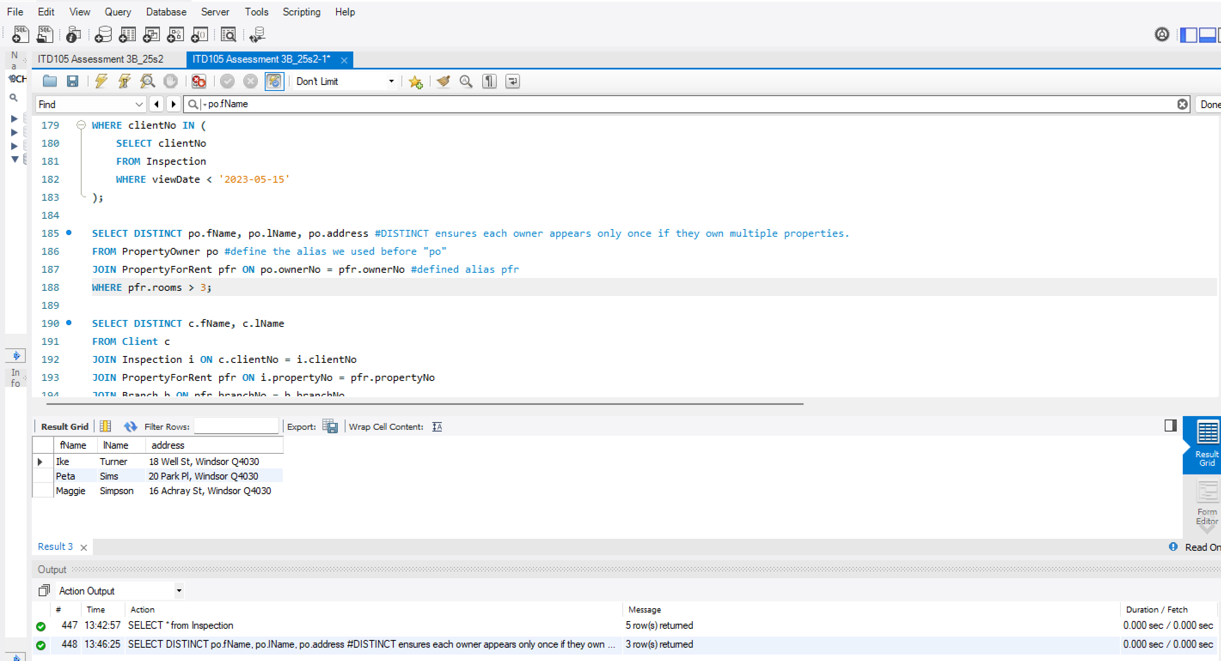

SELECT DISTINCT c.fName, c.lName
FROM Client c
JOIN Inspection i ON c.clientNo = i.clientNo #match client and inspection
JOIN PropertyForRent pfr ON i.propertyNo = pfr.propertyNo #match inspection to the property
JOIN Branch b ON pfr.branchNo = b.branchNo #march property to branch that manages it. All run in sequence which affect the results
WHERE b.postcode = 'Q4044'; #UI
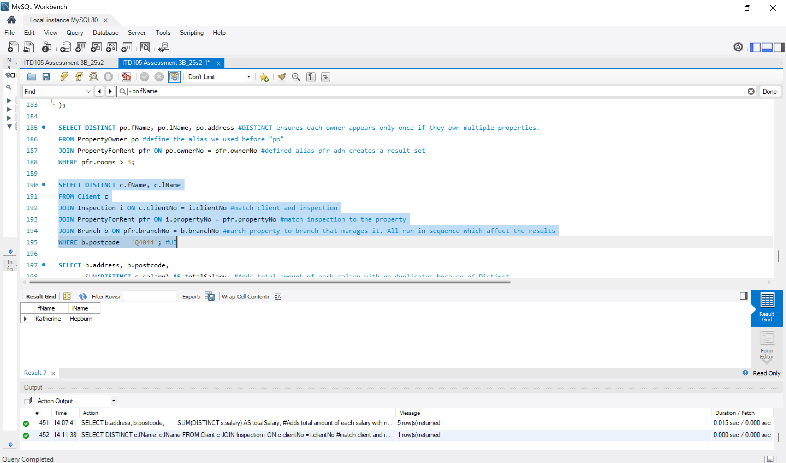
SELECT b.address, b.postcode,
SUM(DISTINCT s.salary) AS totalSalary, #Adds total amount of each salary with no duplicates because of Distinct
COUNT(DISTINCT s.staffNo) AS numEmployees, #Dont want to add staffNo, instead count rows of StaffNo's and properties
COUNT(DISTINCT p.propertyNo) AS numProperties
FROM Branch b #displays
LEFT JOIN Staff s ON b.branchNo = s.branchNo #ensures branches with no staff or properties are included
LEFT JOIN PropertyForRent p ON b.branchNo = p.branchNo #almost like the constraints
GROUP BY b.branchNo, b.address, b.postcode;
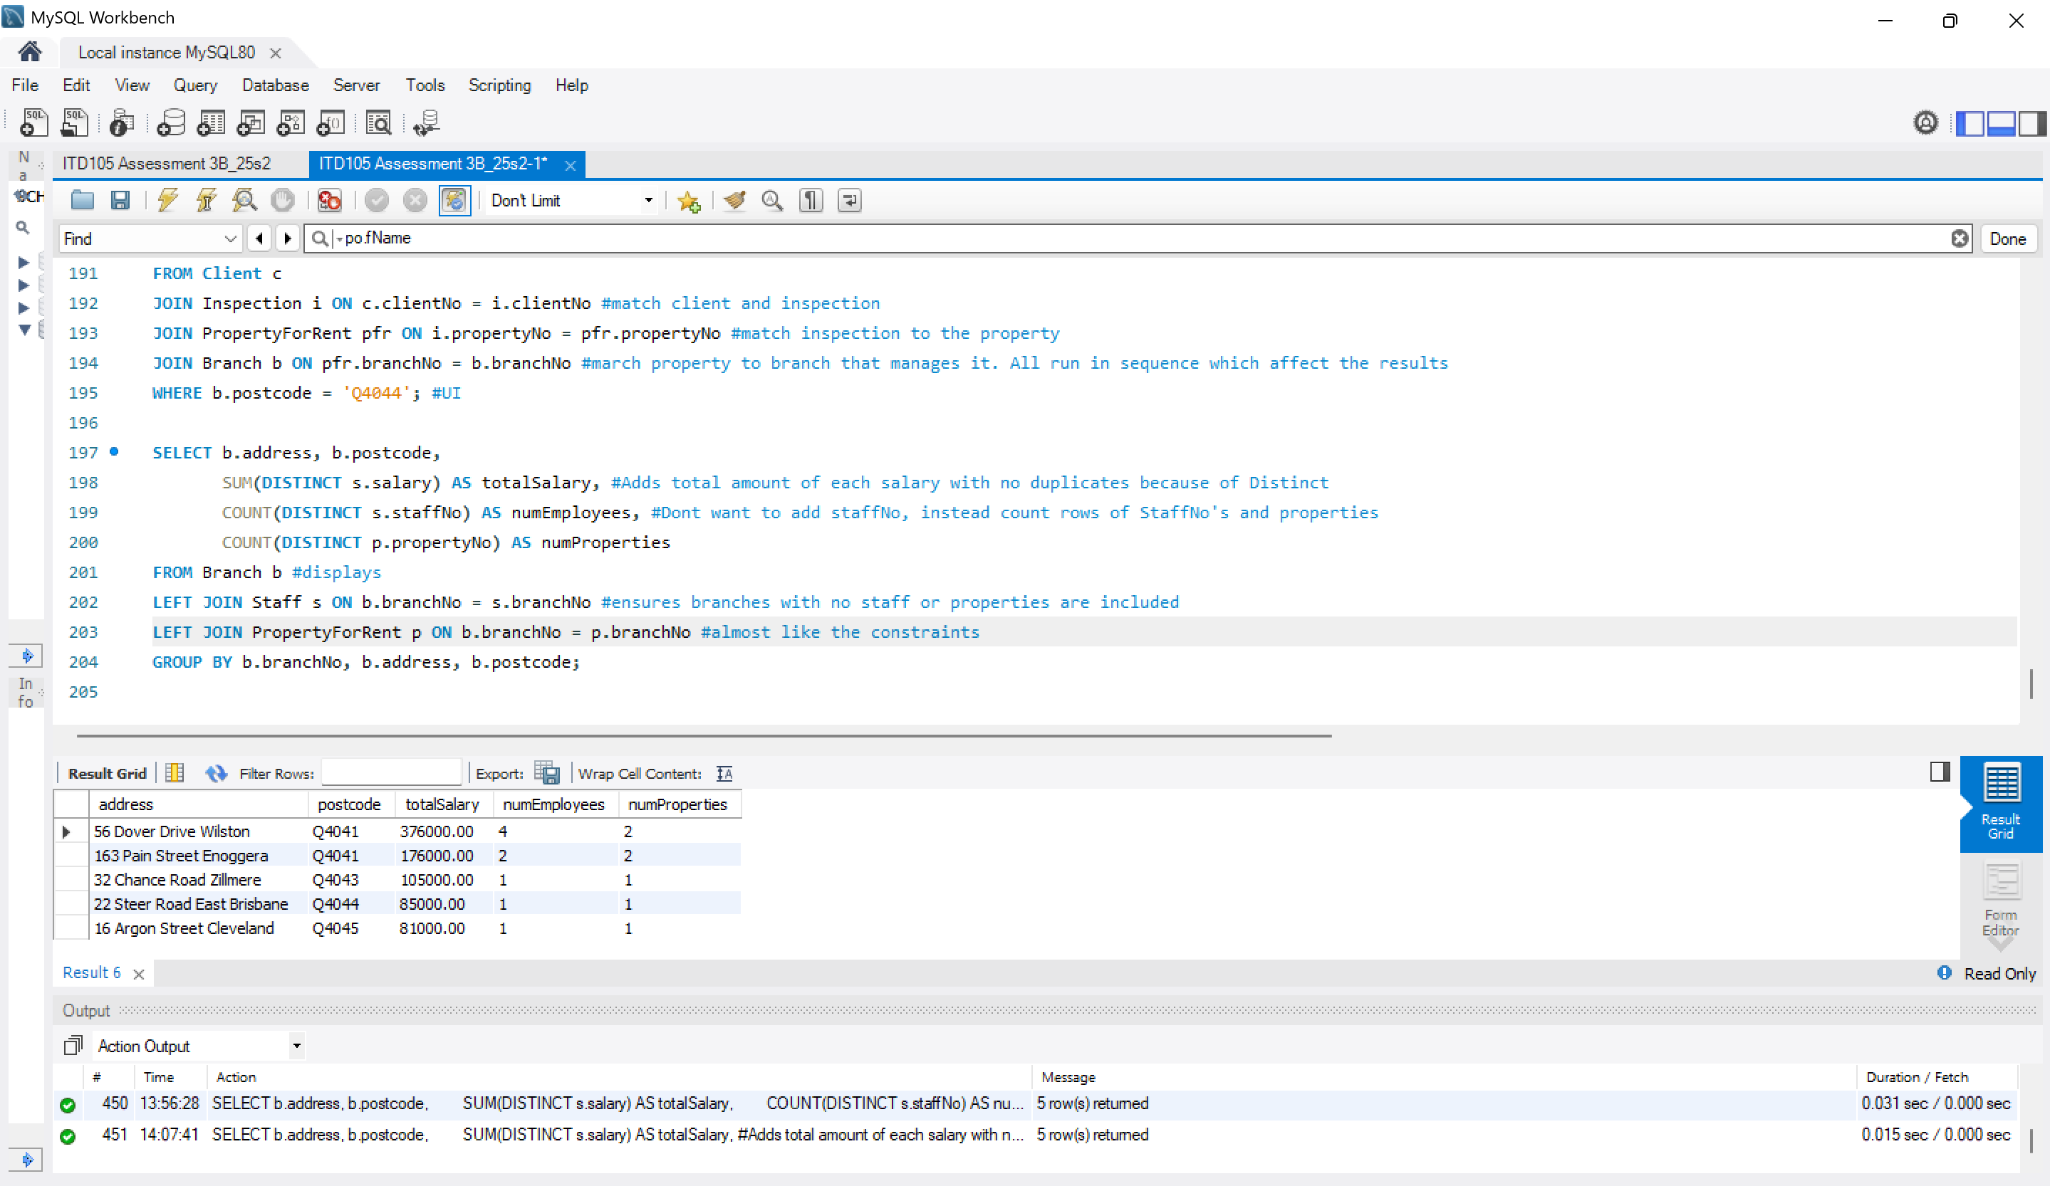
<insert screenshot as requested >
The screenshot (for all parts) needs to include the SQL codes, result grid and action output.

Task 5 [7 marks]

In addition to the screenshots (for all parts), include a SQL script in the file named "ITD105_3B_your_student_number.sql" with your submission. Make sure it clearly shows Task 5.
Please note:
In the following tasks you will be using MySQL Workbench and any question that requires any SQL you must include a screenshot of the result from executing your query.
The screenshot needs to include the SQL codes, result grid and action output as per the example that follows.
- 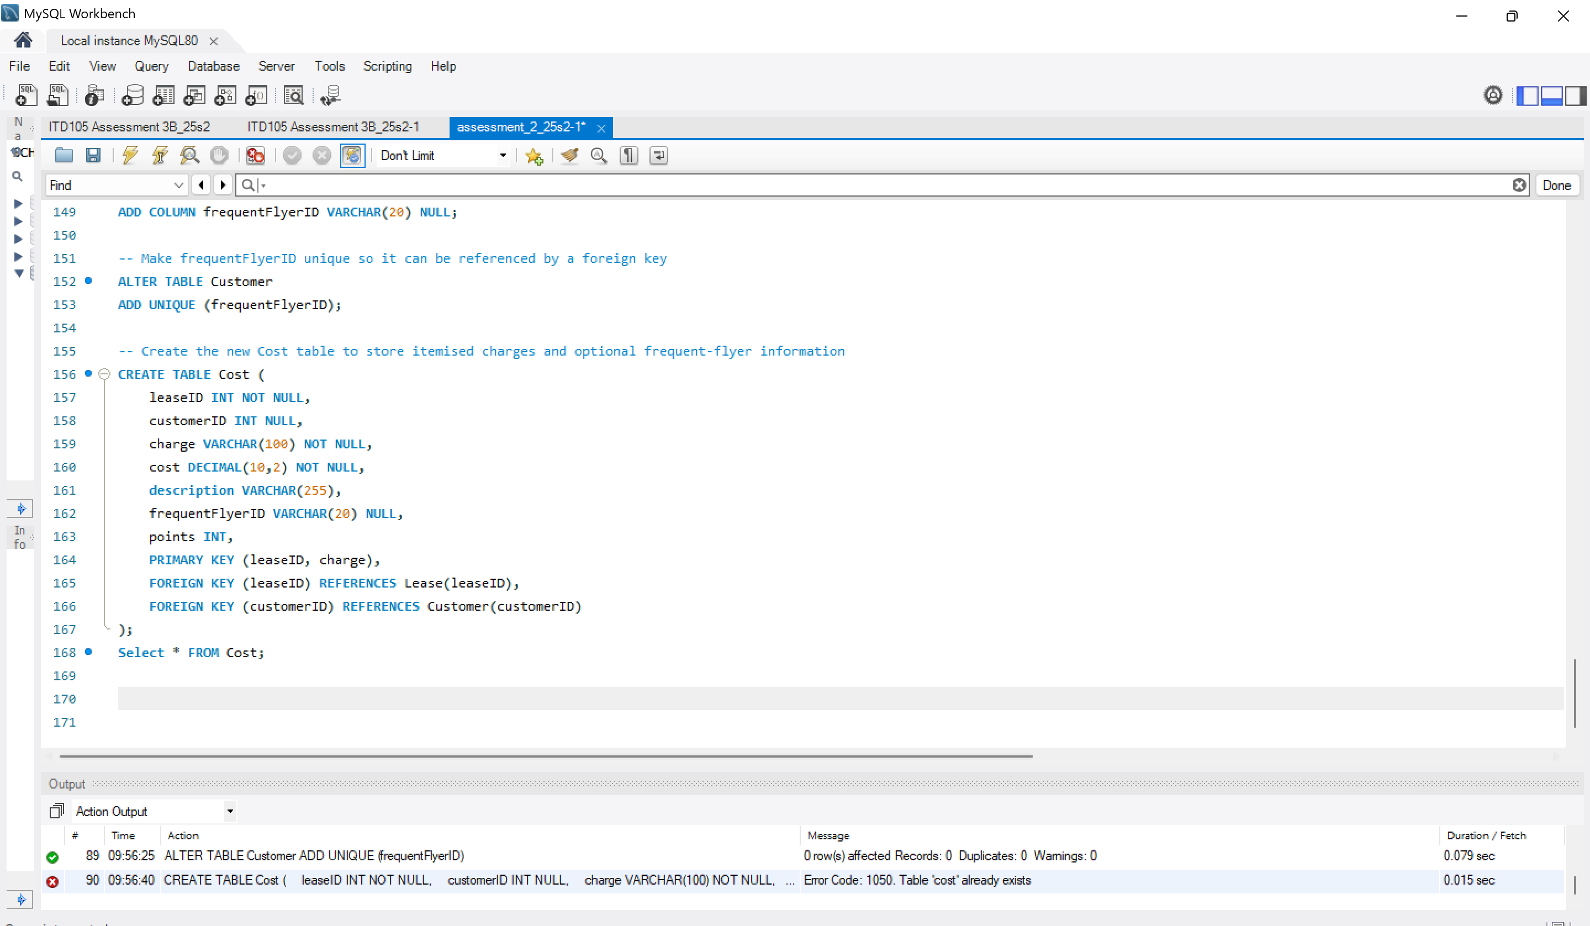
-- Alter the Customer table to add the new frequentFlyerID column
ALTER TABLE Customer
ADD COLUMN frequentFlyerID VARCHAR(20) NULL;

-- Make frequentFlyerID unique so it can be referenced by a foreign key
ALTER TABLE Customer
ADD UNIQUE (frequentFlyerID);

-- Create the new Cost table to store itemised charges and optional frequent-flyer information
CREATE TABLE Cost (
leaseID INT NOT NULL,
customerID INT NULL,
charge VARCHAR(100) NOT NULL,
cost DECIMAL(10,2) NOT NULL,
description VARCHAR(255),
frequentFlyerID VARCHAR(20) NULL,
points INT,
PRIMARY KEY (leaseID, charge),
FOREIGN KEY (leaseID) REFERENCES Lease(leaseID),
FOREIGN KEY (customerID) REFERENCES Customer(customerID)
);
- 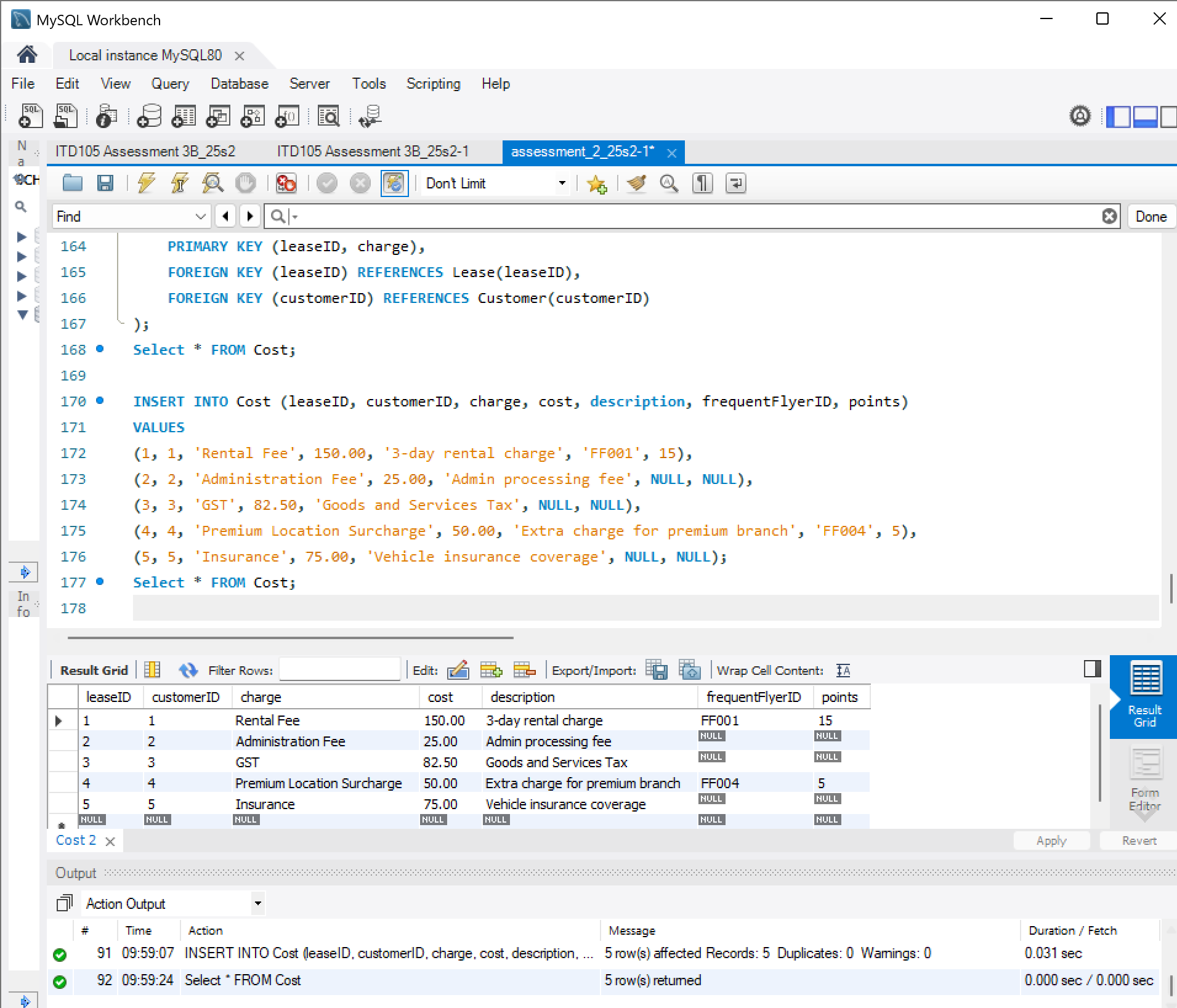

INSERT INTO Cost (leaseID, customerID, charge, cost, description, frequentFlyerID, points)
VALUES
(1, 1, 'Rental Fee', 150.00, '3-day rental charge', 'FF001', 15),
(2, 2, 'Administration Fee', 25.00, 'Admin processing fee', NULL, NULL),
(3, 3, 'GST', 82.50, 'Goods and Services Tax', NULL, NULL),
(4, 4, 'Premium Location Surcharge', 50.00, 'Extra charge for premium branch', 'FF004', 5),
(5, 5, 'Insurance', 75.00, 'Vehicle insurance coverage', NULL, NULL);
- 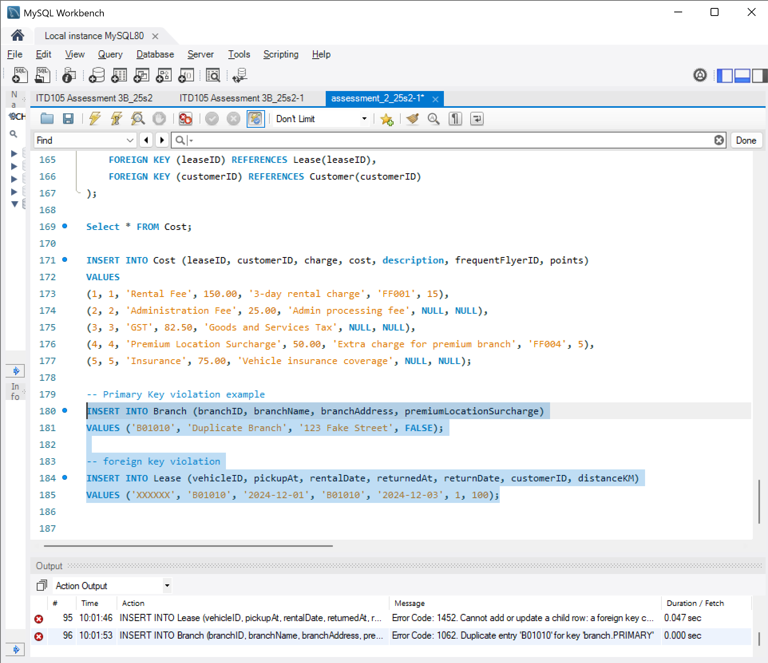

-- Primary Key violation example
INSERT INTO Branch (branchID, branchName, branchAddress, premiumLocationSurcharge)
VALUES ('B01010', 'Duplicate Branch', '123 Fake Street', FALSE);

-- foreign key violation
INSERT INTO Lease (vehicleID, pickupAt, rentalDate, returnedAt, returnDate, customerID, distanceKM)
VALUES ('XXXXXX', 'B01010', '2024-12-01', 'B01010', '2024-12-03', 1, 100);
- 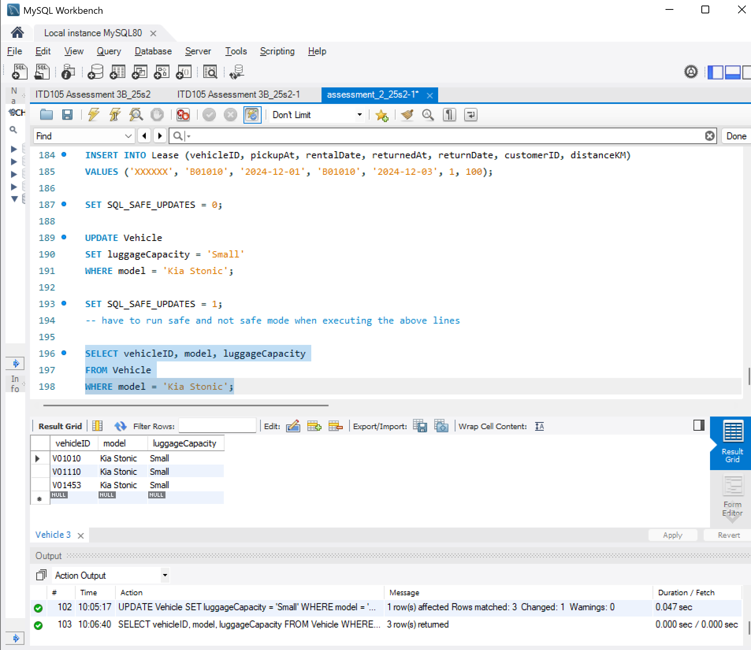
SELECT vehicleID, model, luggageCapacity
FROM Vehicle
WHERE model = 'Kia Stonic';
- 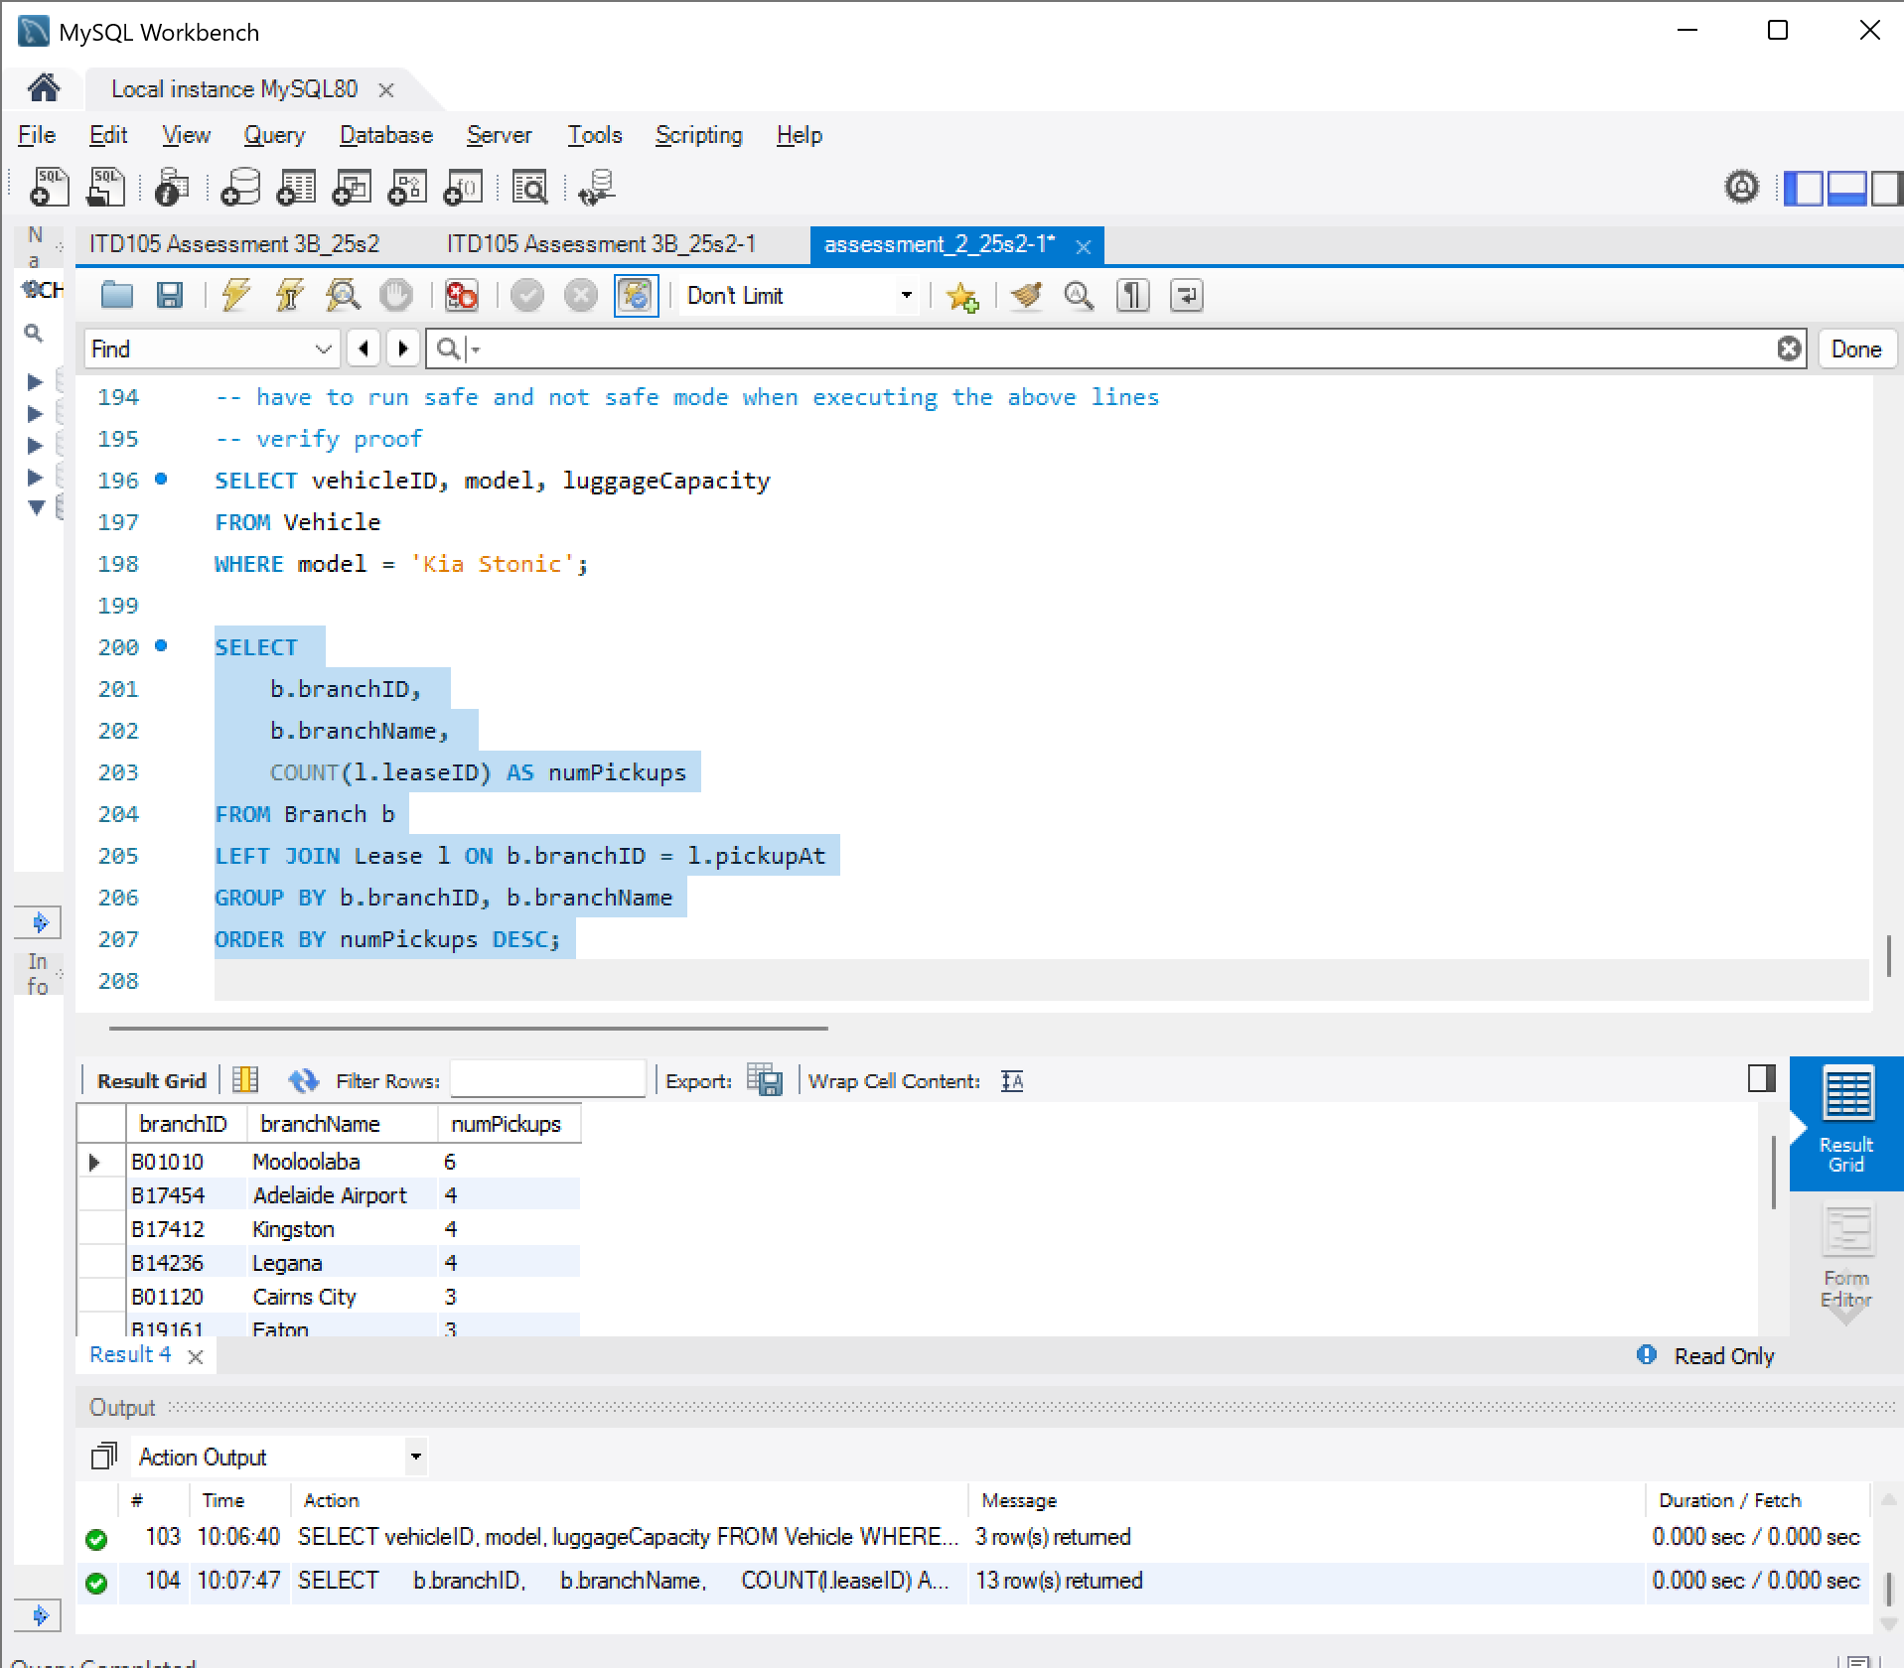

SELECT
b.branchID,
b.branchName,
COUNT(l.leaseID) AS numPickups #counts how many times a vehicle was picked up from each branch.
FROM Branch b
LEFT JOIN Lease l ON b.branchID = l.pickupAt #links each branch to its leases (pickups). if theres a match lease row fills if not NULL. Pickup is matching key
GROUP BY b.branchID, b.branchName #groups results by branch.
ORDER BY numPickups DESC; #shows the branches with the most pickups first.

6.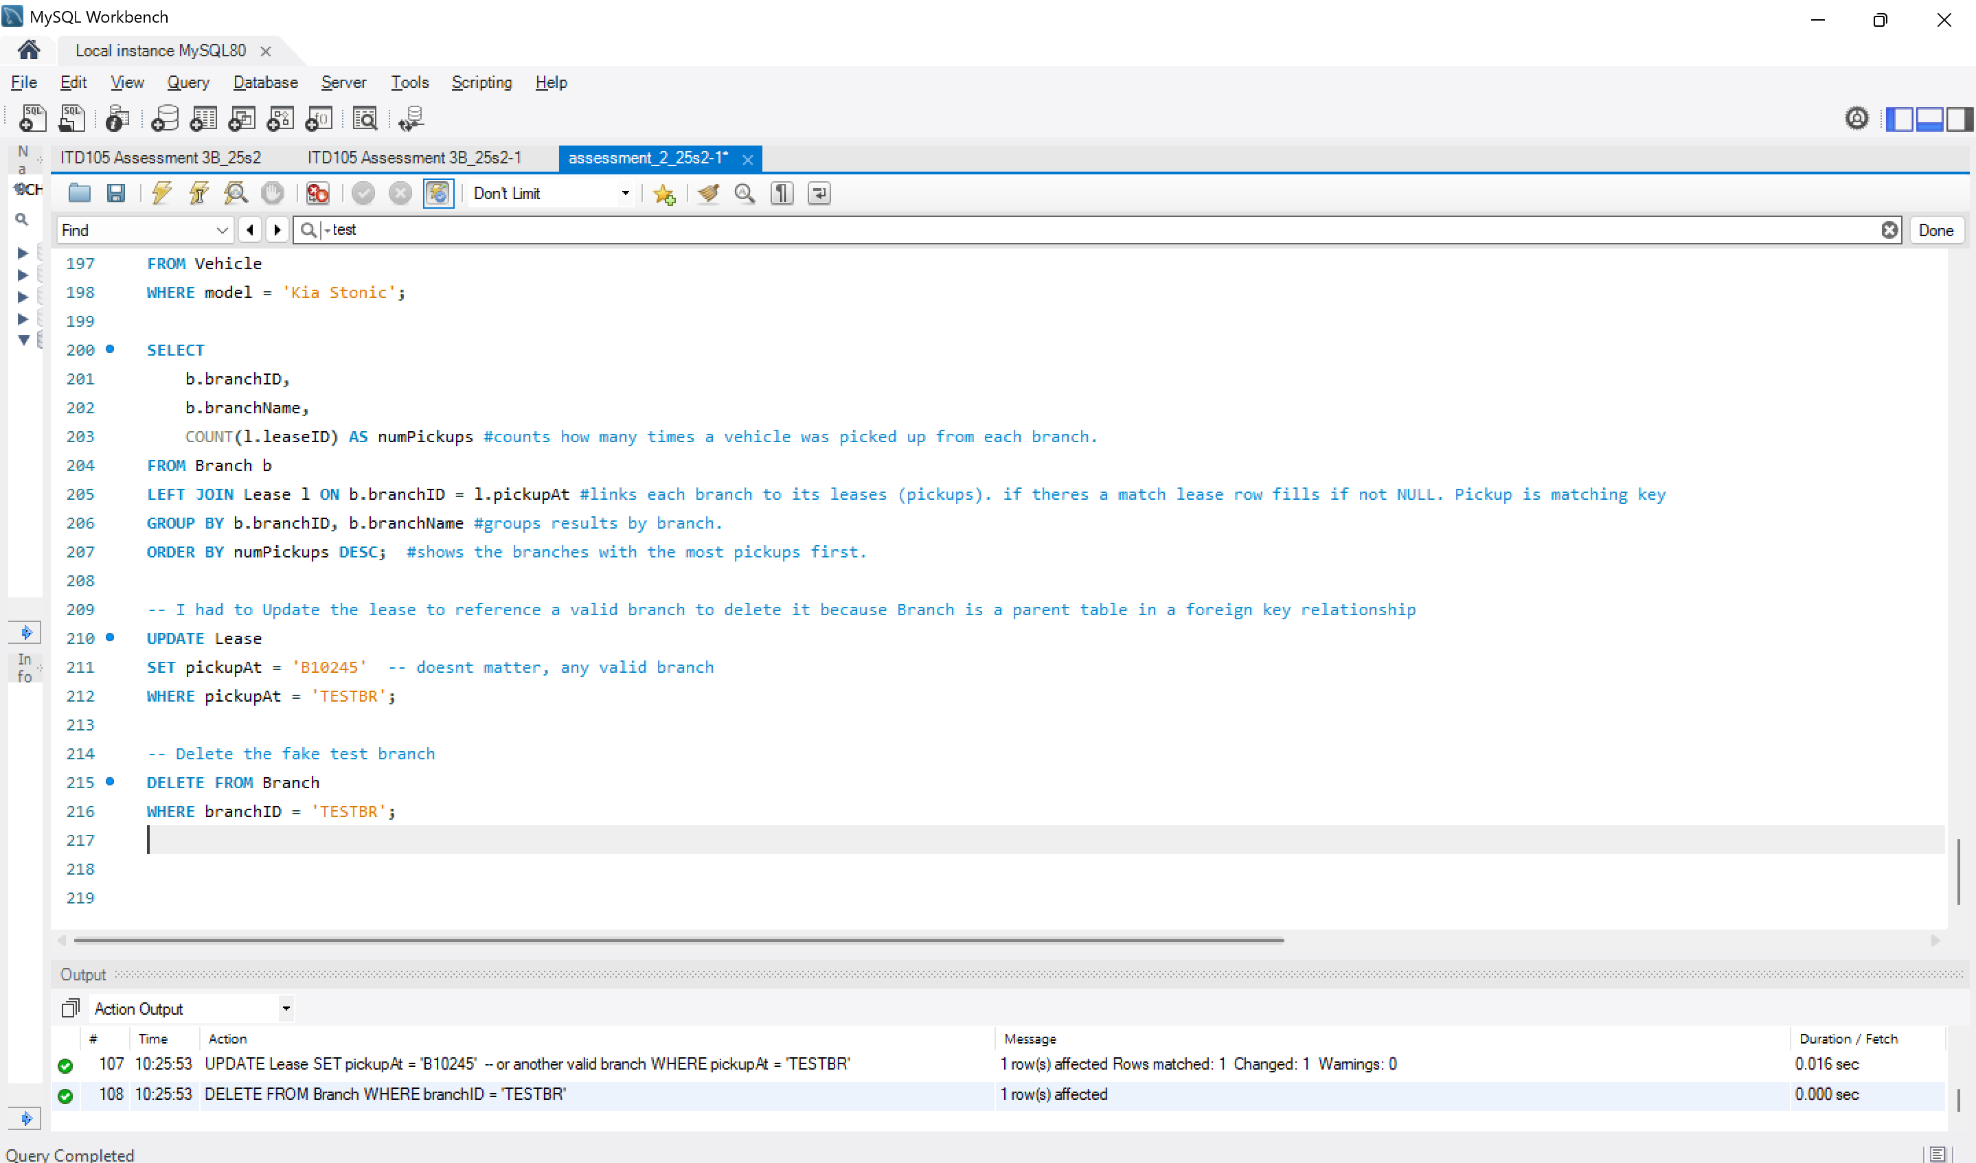

-- I had to Update the lease to reference a valid branch to delete it because Branch is a parent table in a foreign key relationship
UPDATE Lease
SET pickupAt = 'B10245' -- doesnt matter, any valid branch
WHERE pickupAt = 'TESTBR';

-- Delete the fake test branch
DELETE FROM Branch
WHERE branchID = 'TESTBR';

7.
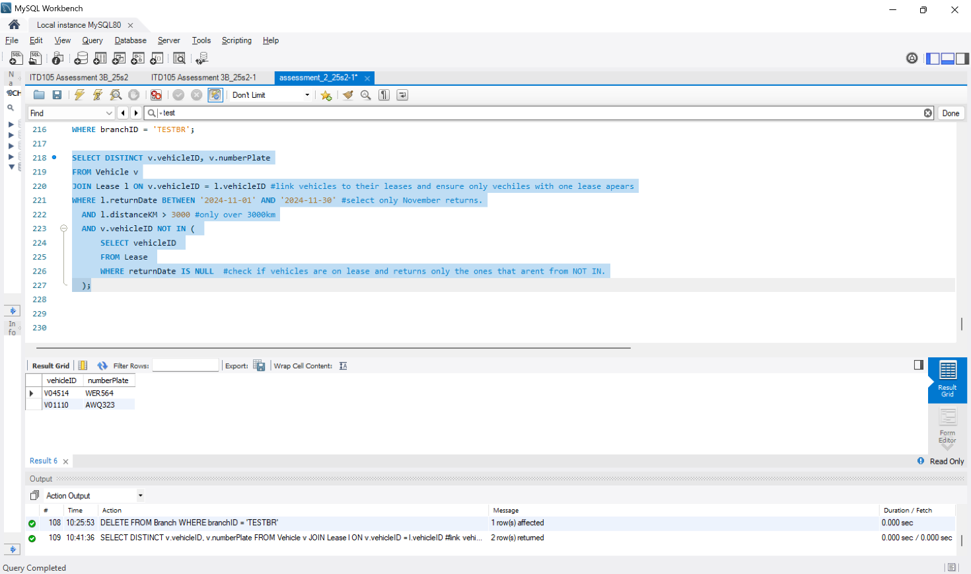

SELECT DISTINCT v.vehicleID, v.numberPlate
FROM Vehicle v
JOIN Lease l ON v.vehicleID = l.vehicleID #link vehicles to their leases and ensure only vechiles with one lease apears
WHERE l.returnDate BETWEEN '2024-11-01' AND '2024-11-30' #select only November returns.
AND l.distanceKM > 3000 #only over 3000km
AND v.vehicleID NOT IN (
SELECT vehicleID
FROM Lease
WHERE returnDate IS NULL #check if vehicles are on lease and returns only the ones that arent from NOT IN.
);

